MRes Bursary Application Form – 2021 Entry
Please complete electronically and email along with a
2-page curriculum vitae to l.ainscough@sheffield.ac.uk
By Wednesday 30th June 2021

Interviews will be held in w/c 19th July (TBC) and we will contact you to arrange a date.

Successful candidates should be able to demonstrate the following criteria:

Essential | Desirable
A minimum grade (or expected grade) of 2.1 in a degree in a related subject. | Practical laboratory experience (especially if related to the area of Musculoskeletal Ageing).
Enthusiasm and motivation to contribute to research in the area of Musculoskeletal Ageing. | Presentation or conference attendance experience (especially if in the area of Musculoskeletal Ageing.

Personal details
Name & title
Contact address
Email address
Contact telephone number
Are you a United Kingdom (UK), European Community (EC) or European Economic Area (EEA) national? |  | Yes/No
If not, do you have indefinite leave to remain in the UK? |  | Yes/No/NA
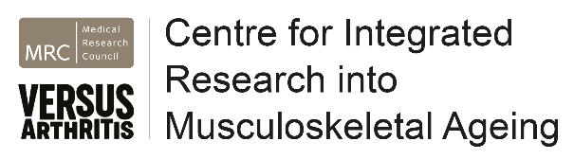
Education, employment, experience
List all university-level qualifications awarded or being studied for, including your expected overall degree grade if you are still studying, giving institution and dates. Include prizes or other academic distinctions.
Briefly (<200 words) summarise any relevant employment, training or experience
Attach a 2-page curriculum vitae and a degree transcripts or summary of results from your institution.

University
Please tick at which University you would primarily be based
Liverpool |  | Newcastle |  | Sheffield
Personal statement
Briefly (< 400 words) explain why you wish to undertake a CIMA MRes.
Referees
1.  Name: |  | 2.  Name:
Tel
Email
May we contact now? | Yes/No | May we contact now? | Yes/No

